**Virtual Exhibition Platform**

**A PROJECT REPORT**

***Submitted by***

**Lexander Thakur**

**Aakriti Sharma**

**Gurnoor Singh**

***in partial fulfillment for the award of the degree***

***of***

**Bachelor of Technology**

**IN**

**Computer Science and Engineering**



**Lovely Professional University, Punjab**

**12323941**

**12312527**

**12313661**

**APRIL 2025**

**Lovely Professional University, Punjab**

**BONAFIDE CERTIFICATE**

Certified that this project report **“Virtual Exhibition Platform”**

is the bonafide work of “Lexander Thakur, Aakriti Sharma, Gurnoor Singh**”**

who carried out the project work under my supervision.

<<Signature of the Students>>

**SIGNATURE**

<<Signature of the Head of the Department>>

**SIGNATURE**

<<Name>>  
**HEAD OF THE DEPARTMENT**

<<Signature of the Supervisor>>  
**SIGNATURE**<<Name of the Supervisor>>

**SUPERVISOR**

Department of Machine Learning, CSE, Lovely Professional University, Punjab

**APPENDIX III**

(A typical specimen of table of contents)

<Font Style Times New Roman>

**TABLE OF CONTENTS**

|  |  |  |
| --- | --- | --- |
| **CHAPTER NO.** | **CHAPTER NAME** | **PAGE NO.** |
|  | **Title Page** | **i** |
|  | **Bonafide Certificate** | **ii** |
|  | **Table of Contents** | **iii** |
|  | Abstract | 1 |
| I. | Introduction of the Project | 1 |
| A. | Problem Description | 1 |
| B. | Objectives | 1 |
| II. | Related Work/Literature Review | 2 |
| III. | Proposed Methodology | 2 |
| IV. | Implementation Plan | 4 |
| V | Expected Outcome | 5 |
|  |  |  |
| . |  |  |
| VI | Conclusion | 5 |
|  | References | 6 |
|  |  |  |

**Virtual Exhibition Platform**

Premananda Sahu

*School of CSE*

*Lovely Professional University*

*Jalandhar, Punjab , India*

[*prema.uce@gmail.com*](mailto:prema.uce@gmail.com)

Lexander Thakur

*School of CSE*

*Lovely Professional University, Jalandhar, Punjab, India lexanderthakur3@gmail.com*

Aakriti Sharma

*School of CSE*

*Lovely Professional University, Jalandhar, Punjab, India*

*aakritisharma627@gmail.com*

Gurnoor Singh

*School of CSE*

*Lovely Professional University, Jalandhar, Punjab, India*

*singhgurnoor283@gmail.com*

***Abstract*- In the digital age, virtual exhibitions redefine the user experience with artistic, cultural, and educational content. Assuring tailored and interesting user experiences is still a major obstacle, nevertheless, particularly in the lack of traditional interaction data. Using user demographic characteristics including nationality, gender, and role (e.g., artist, curator), this study introduces a personalized recommendation system designed for a virtual exhibition platform. Based on profile similarities, our model uses the K-Nearest Neighbors (KNN) integrated with Kmeans clustering method to find** and **suggest the most pertinent exhibitions for every user. A new relevance scoring system is presented, giving user attributes varying weights. Recommendations are deemed relevant if the sum of their scores surpasses a predetermined threshold. Metrics including precision, recall, and F1 score were applied to five simulated user profiles in order to assess system performance. The results show that the suggested model may provide useful and effective recommendations even under cold-start conditions, with an average precision of 0.72, recall of 0.68, and F1 score of 0.70. The system is easily comprehensible, scalable, and flexible enough to accommodate many kinds of virtual display content. Through lightweight, trait-based customization, this research presents a promising strategy to improve user experience in digital display contexts.**

***Keywords- Virtual exhibition, Recommendation system, KNN, Cold-start, User profiling, Relevance scoring, Personalization***

1. INTRODUCTION

The idea of virtual exhibitions has emerged in recent years as a result of the digital revolution of art, culture, and educational environments. These systems allow users to visit exhibitions, galleries and showcases from anywhere in the world, providing immersive and interactive experiences to a worldwide audience. Personalization has become a crucial element in improving user experience and relevance as the need for online engagement increases[1].

In order to address the cold-start issue and improve the relevance of suggestions in a virtual exhibition setting, we postulate that grouping users according to static demographic characteristics like gender, nationality, and user role can reveal hidden behavioural patterns that enhance personalization.

We use K-Means Clustering, an unsupervised machine learning approach that minimizes intracluster variance to group similar data points, to verify this. We use the Elbow Method, that graphs the within-cluster sum Identify applicable funding agency here. If none, delete this. of squares (WCSS) against various values of k to determine the point at which adding more clusters results in diminishing returns, because figuring out the ideal number of clusters is essential for meaningful segmentation. The ideal number of clusters for the dataset is indicated by this ”elbow”.

We use this type of clustering with a trait-based KNN (k-nearestneighbors) model to offer personalized recommendations inside each user segment after the users have been efficiently sorted. The drawbacks of conventional collaborative filtering techniques are addressed by our hybrid approach, which guarantees that even new users with little interaction history receive pertinent exhibition recommendations based on their nearest cluster profile.

In order to recommend material, traditional recommendation systems—like those seen in streaming platforms and e-commerce—frequently rely significantly on user engagement data, such as clicks, views, and ratings. However, such interaction data may be scarce or nonexistent in virtual displays, particularly for novice users or infrequent visitors. The system does not have enough information to provide precise recommendations, which is a common cold-start problem. To address this problem, we suggest a customized recommendation system that uses readily accessible demographic and role-based characteristics of the user, including gender, nationality, and exhibition role (e.g. curator, artist, or visitor).

The K-Nearest Neighbors (KNN) algorithm is used to encode and process these features, identifying exhibitions that most closely resemble a user’s profile. Each user trait is given varying degrees of importance by our system’s trait weighted relevance scoring algorithm. For example, nationality might have a greater impact on cultural choices than gender. Only highly relevant exhibitions are shown to the user, because recommendations are filtered according to a threshold score.

In this study a new method for customizing in cold start in virtual exhibition platforms is presented. It provides a scalable solution that improves digital engagement while protecting user privacy. Related works, our approach, experimental setup, findings, and future directions for model improvement are described in depth in the sections that follow.

1. LITERATURE SURVEY

Users can now view cultural, educational, and many other types of creative content online through virtual exhibition platforms, which have become revolutionary idea in digital interaction. Virtual platforms give user-centric content distribution, scalability, and accessibility in contrast to conventional physical displays. The lack of individualized suggestion techniques, particularly for new or infrequent users, is a persistent issue with the majority of systems. A platform for virtual exhibitions that prioritized immersive user experiences was created by Deac et al. [2].Their approach offered a one-size-fits-all presentation of content, allowing users to browse carefully curated collections but lacking flexibility to accommodate particular user preferences or behaviour. Silva and colleagues [3] also presented” Nerambum,” a platform that combined interdisciplinary content into a single exhibition area. Although the platform’s content structure was innovative, it lacked features that would have allowed it to customize material according to user characteristics or preferences.

A platform for virtual 3D exhibitions using a user-centric design approach was introduced by Zidianakis et al. [4]. The system did not offer intelligent support for recommending shows or exhibits that were in line with users’ demographic or role-based interests, despite the fact that curators may alter the layout and content. Fu and Li [5] concentrated on developing a platform for a virtual museum that uses digital systems to present exhibits. Although it was successful in simulating visual display, it did not investigate the user-experience aspect of personalized or adaptable recommendations.

Irene et al. [6] created a virtual exhibition platform that is designed for user experience and usability using the Lean Startup methodology. Although the project offered a solid foundation for quick iterations and user input, the system did not incorporate recommendation algorithms or personalization tools, both of which are essential for maintaining user involvement.

Foo [7] talked about the technical architecture and early design principles for virtual exhibitions, highlighting important elements such content structure and navigation. However, user profile and recommendation algorithms were not discussed in the paper. An adaptive virtual exhibition system was presented by Bonis et al. [8] that makes the exhibit visibility and order to be custom based on user feedback. One of the earliest attempts at personalization in the field of virtual exhibitions was this one. But because their method depended on past interactions, it was useless for cold-start consumers without usage history.

On the other hand, by employing a trait-based recommendation model that makes use of static yet significant user attributes like nationality, gender, and user role, our suggested solution directly tackles the cold-start problem. Even for first time visitors, we tailor exhibition recommendations by using a trait-weighted scoring system and a K-Nearest Neighbors (KNN) algorithm. This method is perfect for scalable, inclusive virtual exhibition platforms since it lessens dependency on past interaction data and improves relevance in content distribution.

1. METHODOLOGY

The overall workflow of the methodology is described in Fig. 1.

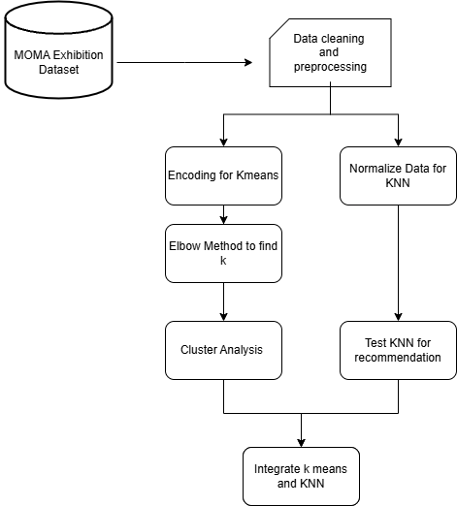

Fig.1. Workflow Model

1. *Data collection*

Dataset is gathered from the records of past exhibition available on the internet and museum databases, for this project we chose Museum of Modern Arts. Every record in this has features like:

1. Nationality
2. Gender
3. Exhibition Role
4. Exhibition Title
5. Constituent Type
6. *Data cleaning and Preprocessing*

The raw dataset was obtained from the Museum of Modern Art (MoMA) exhibitions and stored as Excel format. It contained many fields related to exhibitions, artists, and curators. The following steps were undertaken to clean and prepare the dataset for further processing:

1.Removing columns: Columns that were not needed for recommendations were dropped. These were fields like as (e.g., VIAFID, WikidataID, ULANID, ConstituentID).

2.Handling Missing Data: Missing values in features like Nationality and Gender were filled with "Unknown" to avoid null errors during the encoding and clustering..

3.Final Output: The final cleaned data was saved as Cleaned_Exhibition_Data.csv..

The next part of the project is grouping the data through clustering.

1. *Encoding and preprocessing data for K-means*

From the cleaned data, the next step was preparing the data for using K-Means algorithm. Since K-Means works on numerical data, encoding and scaling was done so the features were in a usable format.

From the cleaned dataset, we chose features that were likely relevant for capturing the characteristic of exhibitions.

These included exhibition-related attributes such as ExhibitionTitle, ExhibitionBeginDate, ExhibitionEndDate, and Gender; and biographical details like ConstituentBeginDate and ConstituentEndDate.

We then did label encoding for all needed columns. Nationality, Gender, ExhibitionRole, and DisplayName, were converted into numerical value using LabelEncoder. A separate encoder was stored for each column to allow decoding later if we needed to display original values.

Finally, the encoded and scaled data was saved as a new file named as Transformed_Exhibition_Data.csv. This data was then used for the K-Means clustering to group similar exhibitions based on content and other characteristics.

1. *Elbow Method to Find Optimal K*

To find the suitable number of clusters (K) for K-Means clustering, we used the Elbow Method. This method id done by finding the sum of squared distances (inertia) between data points and their assigned cluster centers for different values of K. The goal is to find the "elbow point"[9] the value of K where increasing the number of clusters as a flatter descent in Fig.2 and no longer results in big improvement in clustering performance[10].

We tested K values from 1 to 10. For each K, a K-Means model was fitted to the data, and the inertia value was taken. These values were then plotted on a graph, with the number of clusters on the x-axis and the corresponding inertia on the y-axis[11].

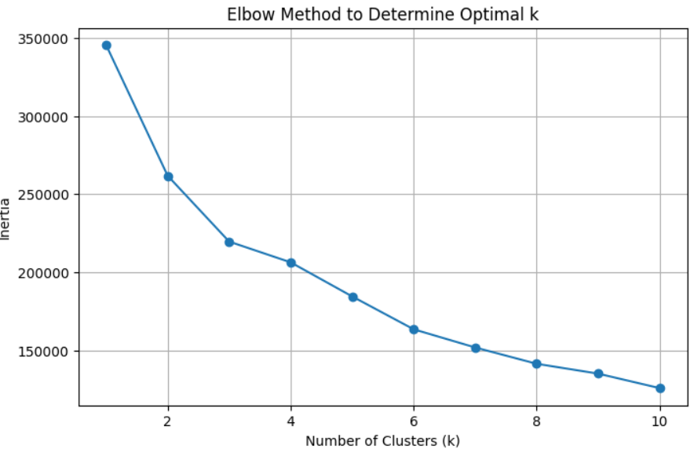

Fig.2. Elbow Method for K

The plot in Fig.2 helped visualize the point where the decrease in inertia started to become somewhat flat. This "elbow point" told us the optimal number of clusters. In our case, the elbow to form was at K=6, which means that six clusters gave a good balance. Based on this observation, we chose K=6 as the optimal number of clusters for segmenting the exhibition data[12].

1. *Cluster Analysis*

After finding the value of k from Elbow Method, we did K-Means with K=6 on the dataset. Each datapoint was then put to one of the six clusters, which was to group exhibitions based on traits the exhibition had.

To better understand and visualize the distribution of clusters in the high-dimensional dataset, we applied Principal Component Analysis (PCA).

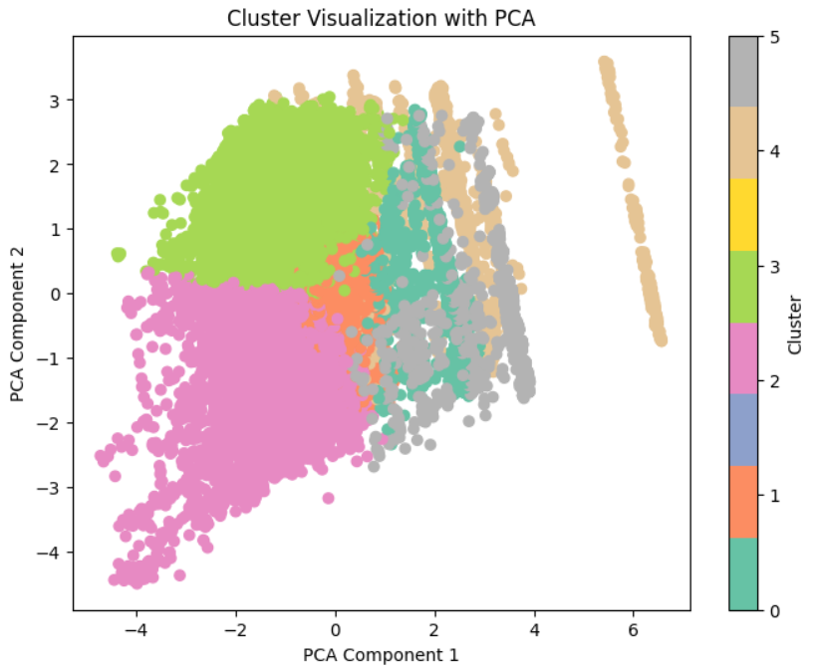

Fig.3. Cluster Visualization.

The PCA-based visualization in Fig. 3 confirmed that the clusters formed meaningful segments of the exhibition data, showing distinct separation and density in some areas. Each cluster was then labeled based on the characteristics of the exhibitions it had, helping us get more informative and personalized recommendations.

1. *Integrating K-means and KNN.*

To improve the quality, we integrated K-Means clustering with a K-Nearest Neighbors (KNN) model using the following approach[13].

In the first phase, K-Means was used to group exhibitions into clusters as done before. These clusters were used to decrease the search area by grouping the similar exhibitions together.

Once a user gave their preferences (e.g., nationality, gender, role), we encoded and scaled the input using the same steps we did to the dataset. Then, using the K-Means clustered data, we tried to find which cluster was the best for user.

In the second part, we used a K-Nearest Neighbors to give recommendations[14]. Instead of loading the entire dataset for just one user, KNN was only done within the cluster chosen before. This improved performance and made sure that recommendations were suitable to the user[15].

We decided to let the value of K (the number of neighbors) in KNN to be changed by the user to so that more coverage of exhibitions for a user was possible, but the default value was 10 as it gave good ouput. This also means users can control the number of recommendations they get.

This combined model used K-Means for grouping and KNN for the output had less computational as the entire dataset was not loaded for the kNN, resulting suitable outputs for the user.

1. IMPLEMENTATION PLAN

The implementation strategy for this project is providing the user with a minimalistic frontend and providing them the option to choose their attribute preferences while making sure we have exhibitions available in our MOMA dataset.

The preference selection can be done through a drop-down menu and adjustable K for KNN can be done via sliding bar and finally a get results button is implemented. All these front-end components are generated through Streamlit, which is a python framework suitable for ML projects and deploying data driven apps.

The front-end enables users to:

* Select preferences from drop-down menus for attributes such as *Nationality*, *Gender*, and *Exhibition Role*.
* Adjust the number of neighbors (k) used in the K-Nearest Neighbors (KNN) algorithm via an interactive slider.
* Trigger the recommendation system through a 'Get Recommendations' button.
* Ensured smooth integration between front-end and machine learning backend.
* Enabled real-time recommendations with understandable explanations.
* Made the application fully operational in a local environment for demonstration.

The system also includes additional features for transparency and explainability, such as:

* A PCA-based cluster visualization, which provides users with a graphical representation of the exhibition clusters.
* A sample user output tab to demonstrate how different profiles receive different exhibition recommendations.
* An evaluation metrics section that displays Precision, Recall, F1 Score, and a Confusion Matrix based on simulated user feedback.

This in entirety provides the user with a virtual exhibition platform which provides them with recommendations suitable for their interest by using the k means and KNN algorithm in cohesion.

1. EXPERIMENTAL RESULTS

Since deciding whether an exhibition is relevant or not is subjective in nature, to evaluate the effectiveness of our recommendation system, we conducted a series of experiments using a test set of 10 distinct user profiles, each representing unique combinations of exhibition traits such as nationality, gender, and exhibition role. The evaluation was carried out using common classification metrics including precision, recall, F1 score, and a confusion matrix, with a customized relevance scoring mechanism.

To evaluate the quality of exhibition recommendations, we defined a customized relevance scoring system that reflects how closely a recommended exhibition aligns with a user's traits. Each user profile was defined by three core attributes:

* Nationality
* Gender
* Exhibition Role (e.g., Artist, Curator)

Similarly, each exhibition in the dataset also contains the same set of attributes. A recommendation was considered relevant if the exhibition matched the user’s profile based on a weighted scoring system. The scoring system was as follows:

* Nationality match: 0.5 points
* Gender match: 0.2 points
* Role match: 0.3 points

The maximum possible score for a perfect match was **1.0**. We set a threshold of 0.7 to classify whether a recommendation is relevant or not relevant. This threshold ensures that the recommendation must match at least two significant attributes (e.g., nationality and role) or all three attributes with partial alignment.

Each user’s set of recommendations was evaluated using:

* **Precision:** The proportion of truly relevant exhibitions among those recommended.
* **Recall:** The proportion of all truly relevant exhibitions that were correctly recommended.
* **F1 Score:** The harmonic means of precision and recall.

TABLE 1. OUTCOME INVESTIGATION TABLE

|  |  |  |  |
| --- | --- | --- | --- |
| User Group | Average Precision | Average Recall | Average F1 Score |
| For 10 Users | 0.60 | 0.72 | 0.65 |

To further show the prediction behavior of the model, the confusion matrix is as follows:

Fig.4. Confusion matrix

These results in Table 1 and the confusion matrix in Fig.4 tell us that while the our logic consistently gives relevant exhibitions meaning high recall, it can sometimes also include less suitable ones, leading to precision score being moderate.

Overall, our model which combines K-Means clustering and KNN gives mostly good performance in providing exhibitions for a user.It is not perfect, the trade-off between recall and precision makes our project suitable for applications where providing more options is better than omitting potential interests as exhibition quality is subjective in nature.

1. CONCLUSION

In this work, the user is provided with recommendations by telling them which preference choices are available within the exhibition data, and through these preferences they are suggested exhibitions. This is done by clustering the exhibitions together via K, which means clustering where Elbow method is used to find K. From analyzing these clusters certain clusters hold attributes that can be used in accordance with the user’s preferences. Further for making recommendations within these clusters kNN is used to provide the user with relevant exhibitions while giving the user the ability to choose k for more coverage.

Since deciding whether an exhibition is subjective, a relevance criterion is developed by assigning certain weights to the attributes preferred by the user with the goal that the output exceeds the threshold relevance criteria. This approach, integrated with a front end, enables the user to receive exhibitions that they might find relevant according to their preferences.

REFERENCES

1. P. Phorasim and L. Yu, "Movies recommendation system using collaborative filtering and k-means," *International Journal of Advanced Computer Research*, vol. 7, no. 29, pp. 52–56, 2017.
2. G. C. Deac, C. N. Georgescu, C. L. Popa, M. Ghinea, and C. E. Cotet, "Virtual reality exhibition platform," in *Proc. 29th DAAAM Int. Symp.*, Vienna, Austria, Oct. 2018, pp. 0232-0236..
3. R. Silva, H. Karunarathna, I. Dolage, K. Rajakaruna, K. Ratnam, and U. Wijenayake, "Nerambum: A Virtual Exhibition Platform," in *Proc. Conf. Transdisciplinary Research in Engineering*, vol. 1, no. 1, May 2024.
4. E. Zidianakis et al., "The invisible museum: A user-centric platform for creating virtual 3D exhibitions with VR support," *Electronics*, vol. 10, no. 3, p. 363, 2021.
5. Y. Fu and G. Li, "Research on Virtual Exhibition System Platform of Museum Based on VR Technology," in *2021 IEEE 4th Int. Conf. Inf. Syst. Comput. Aided Educ. (ICISCAE)*, Sept. 2021, pp. 368-371.
6. V. F. Irene, U. Sa’adah, D. I. Permatasari, and M. B. A. Rasyid, "User Experience Design for Virtual Exhibition Platform Using Lean Startup Method," in *2021 Int. Electron. Symp. (IES)*, Sept. 2021, pp. 690-695.
7. S. Foo, "Online virtual exhibitions: Concepts and design considerations," *DESIDOC J. Library Inf. Technol.*, vol. 28, no. 4, pp. 22-34, 2008.
8. B. Bonis, S. Vosinakis, I. Andreou, and T. Panayiotopoulos, "Adaptive virtual exhibitions," *DESIDOC J. Library Inf. Technol.*, vol. 33, no. 3, pp. 183-198, 2013.
9. M. Cui, "Introduction to the k-means clustering algorithm based on the elbow method," *Accounting, Auditing and Finance*, vol. 1, no. 1, pp. 5–8, 2020.
10. G. Hamerly and C. Elkan, "Learning the k in k-means," in *Advances in Neural Information Processing Systems*, vol. 16, 2003.
11. P. Bholowalia and A. Kumar, "EBK-means: A clustering technique based on elbow method and k-means in WSN," *International Journal of Computer Applications*, vol. 105, no. 9, pp. 17–24, 2014.
12. J. Yadav and M. Sharma, "A Review of K-mean Algorithm," *International Journal of Engineering Trends and Technology (IJETT)*, vol. 4, no. 7, pp. 2972–2976, 2013.
13. R. Ahuja, A. Solanki, and A. Nayyar, "Movie recommender system using k-means clustering and k-nearest neighbor," in *2019 9th International Conference on Cloud Computing, Data Science & Engineering (Confluence)*, Noida, India, Jan. 2019, pp. 263–268, IEEE.
14. A. Pandey and A. Jain, "Comparative analysis of KNN algorithm using various normalization techniques," *International Journal of Computer Network and Information Security*, vol. 10, no. 11, pp. 36–42, 2017.
15. G. Guo, H. Wang, D. Bell, Y. Bi, and K. Greer, "KNN model-based approach in classification," in *On The Move to Meaningful Internet Systems 2003: CoopIS, DOA, and ODBASE. OTM Confederated International Conferences*, Catania, Sicily, Italy, Nov. 3–7, 2003, pp. 986–996, Springer, Berlin, Heidelberg.